Task from Andre
Continue implementinrg project wich started last developer of DatacardViewer – implement feature after what DatacardViewer can read multiple .root files.
And complete lefted tasks from latest development:
- Add Multiple root files support. Suggestion: create an object to store: filename => keylist.
- Figure a way out to support root files with "RooWorkspace". Suggestion: Update JSRootIO to the newest version when possible, maybe support will be added.
- Add "Configuration" to application, to adjust settings e.g. "MASS" parameter.
- Redo "3 in 1" drawing from HStack to Custom.
- Redo "3 in 1" plot loading from ALL to ON SELECTED.
- Improve datacardShapeMap parser.
- Fix environment for Datacard.py and DatacardParser.py.
- Add "Others" dialog in nuissances menu.
- Improve current search, to search/sort by bin/proccess/nuissance.
- Add Server uploader response to the client.
- Add smartlinks for datacards.
- Improve Andrius documentation.

Plans(07/01 ~ ?)
First Task for me this week will be to understend how everithing works.
Last developer has an application package were locates JS, Pyhon, HTML, CSS + lib's and unknown JS, Python frameworks.

Workflow
Configured /afs to get to Datacards + root file Examples /afs/cern.ch/user/g/gpetrucc/public/CMSDAS-2014-CERN-cards.tar.gz
afs
etc/rb5-config
$ kinit user@CERN.CH # get kerberos ticket
$ aklog # login to AFS cell

Starting understanding ROOT:
ROOT is a framework for data processing.
Some resources from root.cern.ch advise me Tutorial with ROOT configuration on PC.
y
Installed Oracle VM VirtualBox https://www.virtualbox.org/wiki/Downloads
Run ROOT6 on VM
http://cernvm.cern.ch/releases/ROOT%206.ova

First run ROOT
TFile::Open("http://lcg-heppkg.web.cern.ch/lcg-heppkg/ROOT/eventdata.root");

Thing that I touched for first few weeks
Study ROOT
Create Virtual Machine and run ROOT on it
Run Andrius project and analize UI
Created access to /afs
Get introduce to Higgs Bosson
Touch Client side AngularJS
Analize Flask framework. Creating own applications to get things on
Look for JS and Angularjs
Analizing DataCardViewer
- First steps (downloading)
Practice started from bundle of code snippets, which was deployd by earlier p trainsheep.
First steps was downloading from github: (https://github.com/aPoluden/HiggsAnalysis-CombinedLimit.git) reposytory project which named CombinedLimit (ask Andre for explain) . To do that was created github.com account. Generated SSH key.
2. Second step unpacking the package
What I will work for is Located in HiggsAnalysis-CombinedLimit/test/DatacardViewer. DataCardViewer is the WEB application which let physics from PH CMS analaze Higgs measurements easier. So DatacardViewer provides GUI. At this moment DatacardViewer is not fully prepeard for mass usage.
3. Package snacks
all off the package content is documented by Andrius Versockas. I will only write some place detalisation. For the future plans create some Tutorial for finished project.
4. Code snippets dependencies.
At this point I prefer to document the code that won't be changed while adding features to DatacardViewer.
Used Lib's
- Flask(Python framework) – used to create Python servers. http://flask.pocoo.org/
- AngularJS – Javascript strucrural framework for dynamic WEB applications https://docs.angularjs.org/guide/introduction
- Bootsrap – framework for HTML, CSS, Javascript http://getbootstrap.com/
- jQuery – rich of features Javascript lib http://jquery.com
- HandsonTable – is a minimal Excel-like data grid editor for HTML, JavaScript & jQuery http://handsontable.com/

Main gols of using listed lib's -frameworks
Flask
DatacardViewer is the WEB application wich need to be located on the server. Previos developer choose Flask framework, beacause it's light weight and have a good performance. So when user enters domain to DatacardViewer app first he sends request via HTTP protocol to get all needed stuf from server. CSS, frameworks, libs, CSS, HTML.
Angularjs
Angularjs is used as a main JS framework which provides interface with backend and frontend. Allways Angularjs used for dinamical WEB app's as mentioned above.
Bootsrap
Bootstrap framework, makes DatacardViewer application preaty look.
JQuery
JQuery is used in contact with bootsrap to provide file upload feature. Everything what is needed to upload files with (.txt and .root) extensions fitted to one js lib.
HandsonTable
Handsontable lib is greate choice to plot dinamicall tables with Excell disigne.

From button press to Histogram or Frameworks behave
Here will be explained(not detailed) how we get the DatacardViewer(DCV) scripts behave.
File upload to server
Uploading feature to Flask server is used jQuery lib named (jquery.fileupload.js). More detailed information provided on jQuery provider web page. This lib feature handles Angularjs controller – DemoFileUploadController which gets selected files references as array. To upload selected files to DCV /upload folder is used submit() function with POST method wich handles jQuery.
When the files are uploaded to DCV /upload folder they appers in toogle-bar list(tab#1). Choose the one of them and lets trip to the code more deeper. So when user pushes one of the datacard reference in toogle list the get_datacard(datacard) method is called which locates in angullarApp.js > ViewDatacardsController. So then called HTTP GET request to the server script > datacards.py. Which returns jsonString of parsed datacard.txt . Here we should stop and explain bit more about called python function def uploaded_file(filename).
datacards.py(uploaded_file(filename)) uses DatacardParser.py script to parse the cards. DatacardParser.py script extended by Datacard.py class who creates Datacard() object.
JsonString contains : filename, observation, binsProcessesRates, nuisances, shapeMap.

Second step ufter succes to get jsonString object, this object is used in main.js script function
show_datacard(jsonString). This function contains three other functions which call sequence is : 1. init_variables(), 2. parse_datacard(jsonString) 3.generate_datacard()

init_variables() - method is used to initilize global variables for one Datacard() object.

parse_datacard(jsonString) this metod parser jsonString and refer them to main.js global variables. After parser finishes his work, called init_JSRootIO() function, which calls assertPrerequisitesAndRead() function which locates in loadJSRootIO.js. AssertPrerequisitesAndRead() is used to load JSRootIOv2.1.js framework to client side. Wich helps to parse datacards.root files and get graphs From them. After all framework scripts loaded readRootFiles() function is called.
ReadRootFiles() - checks the browser version, and then checks the length of rootJsFiles array. If Array.length < 2 creating gFile object wich holds JSROOTIO.RootFile object with current card url If Array.length> 2 program stops her workflow for parsing multiple datacards.root

generate_datacard() - plots from initiated variable using Handsontable framework table for parsed Datacards.txt

Plans for future provide a User guide.

Add Features to DataCardViewer

Adding config.py
While working on implementing DCV have been invented security issue. The simpliest security feauture needed to be added to the DatacardViewer is CSRF (Cross-site request forgery). This feature need to be turned on in config.py > CSRF_ENABLED = True. It will prevent from one-click attack or session riding[http://en.wikipedia.org/wiki/Cross-site_request_forgery]. Try to test CSRF. In simple words, attacker can add weird script that will use client personal data to perform unwanted operations.

Adding button's to remove Current data card from view.
Work directory: DatacardViewer/application/static/js/angularApp.js;
DatacardViewer/application/template/index.html
Client side
While working with Andrius created project, I found an issue that, while selecting datacards we canno't remove existing datacard table. So I Provide delete button named “Remove table”. Button is unactive until the Datacard is selected. This function let user to empty screen from selected datacard. This function hava no need to be provided, bet let me to deeper understand how angularjs is working. Client side.

Work directory: DatacardViewer/application/static/js/angularApp.js;
DatacardViewer/application/template/index.html ;
DatacardViewer/application/datacard.py
fix import in uploaded_file()
Client Server side
Other button named “Delete current card” is needed to remove Datacard from the server. It prevents user hardcoding on the server side to remove cards. So button named Delete datacard, deletes, currently selected datacard from uploaded/<datacards> directory, and refreshes the toggle-bar list.

Adding Warning message
While working with htt_ proccesse I found that path to Datacard.root can be different. For example DCV /uploads directory contains Datacard.txt and Datacard.root in the same directory. But some so in Datacard.txt path to Datacard.root should be without any path(../common/Datacard.root – wont work). Now DCV detect if it was path and Warns user to change path in Datacard.txt

Adding $MASS to Path ?

Plans(07/29): When the datacard removed from /uploads folder(server side) user need to restart the whole page what is very costly. So we will fix that issue reloading only toogle-bar. Other specification add some exceptions to code to prevent of uncknown sign appering on main screen.
Result: Today I was visiting CMS and OpenLab. There was no a lot of time to implement this feature to WEB application. Was added factory service to the - DatacardViewer/application/static/js/angularApp.js. This service let user to acess functions and variables, from multiple controllers, what is very easy to put all things together and take from one place. So main reason why today was not finished my plan is that added service to DeleteDatacardController stop processing his own function.

Plans(07/30)
Fix the problem from 07/29.
Result:Problem fixed. I was using the factory service, but it won't let to use $scope. So was decided to put all implemented methods to DatacardViewerController. Now features works fine

Plans(07/31)
Fix Table Layout
Result:While I was working with DatacardViewer Everithings work fine until one day July 24 table plotting changed. First that I Thought that it's my fault because I was testing the code. I patched project from, Original no soceed. Then I run untouched project and problem was same. Then I investigated that DCV has dynamical href to hands on table in DOM. On the Handsontable Web I found that this day was released new handsontable frame work what was cousing the problem. The new beta version handsontable is 0.11.0-beta3. Old ones version 0.10.5. So I found on WEB old fixed version and staticaly putted it to /aplication/static/lib/jquery-handsontable-0.10.5/. And changed path to jquery.handsontable.full.js and jquery.handsontable.full.css scripts in DOM. Issue fixed.

Plans(08/01)
when the toogle-bar shows zero, upload folder is not totaly empty. There are still .root files left. So we need to add some more code to remove dependency .root files.
Result: application/static/js/main.js script when datacard loaded holds all parameters and values of current datacard to plot Handsontable (bins, processes, niuances etc.). From this script was selected rootjsFiles[] array variable which holds all .root file names speciafied for current Datacard. From now user can remove all uploaded stuff (.txt & .root) from server.

Plans(08/04)
Understanding the Datacard.txt
Main reason why Dacardaprser is created is that PH scientists used .txt datacards to serf in it convension of requered histogram bin/proccess/niussance.

Hitting datacard shield
Datacard.txt
Every datacard.txt has name for example this time I will parse htt_mt_5_8Tev.txt. Datacard.txt holds number of proccesses , background proccesses, signals. For the more most of Datacards.txt have a path to the curent bin/proccess/signal shape which locates in Datacard.root files. For the more Everydatacard can hold from 1 to N path's to current shape. And what's more current Datacard.root can hold multiple shapes for current signal.

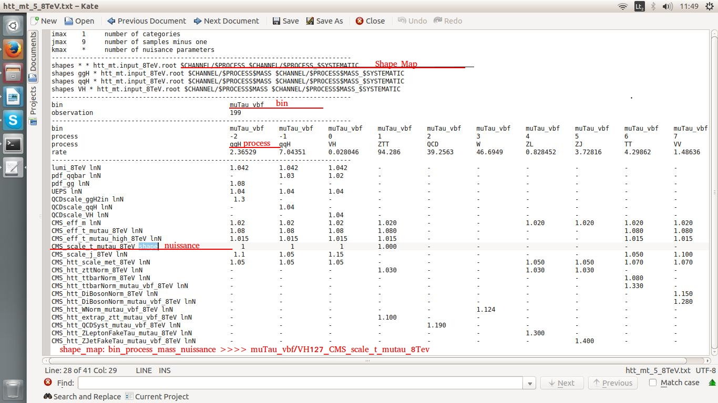
Fix Shape

Datacard.root
Datacard.root - machine-independent compressed binary format, which provides ROOT. Root files can contain directories, histograms. One root file can contain a lot of histograms which all need to be added to one canvas.

Plans(08/06)
Get number of histograms in current datacard. A BUG. Sometimes Server need to be reloaded, because he stucks in readRootFiles() and throws “Not yet loaded, close it and try again” message.

PyROOt interface workframe between client and THTTPServer
Git
1. First steps install git on your local machine. Generate SSH key. SSH key have two parts private key and public key.
2. Go to location where you would like to initilize git
3. In that location print $git init
4. Then check status of the current project $git status
5. Add your project to staging area $git add <filename.ext> or $git add. - to add all files
(to remove file(s) from stagin are use $git reset HEAD – path/to/file | $git reset HEAD)
6. Add commit for changes $git commit -m ''Your message”
7. To see changes have bee made run $git log
8. Push local repo to git server use $git remote add origin https://github.com/master/repo_name
9. $git push -u origin master.
10.$git pull origin master. check for changes on our GitHub repository and pull down any new changes by running
11.
ssh -Y apoluden@lxplus.cern.ch

set up a few shell variables like $PATH.
ssh -Y lxplus
source /afs/cern.ch/sw/lcg/contrib/gcc/4.8
source /afs/cern.ch/sw/lcg/app/releases/ROOT/6.00.01/x86_64-slc6-gcc48-opt/root/bin/thisroot.sh

DataCard Viewer:
Serveris pasileidžia: run.py ->application.__init__.py -> application.views.py -> application.datacards.py
Paleidi Viewerį (įvedi IP): views.py -> index.html -> static/lib/* -> static/js/* ir static/css/* (žiūrėk į šitus)
toliau priklauso ką paspaudi
index.html -> ViewDatacardsController (static/js/angularApp.js ) -> show_datacard (main.js)

